

Instructions for Installation 51-20998 Honda Talon Soft Door Kit
(HO-TALON-SDK01)

CAUTION: Do not smoke inside the cab or expose the enclosure to direct flames. Product is FLAMMABLE.

Be sure to read these instructions thoroughly before opening and installing the enclosure. The installation is best done when the temperature is 70°F or warmer. If installed outside and in the cold weather, warming the adhesive Velcro strips just before installation is recommended.

- Carefully open the carton and roll out the enclosure on a large flat surface that is clean and free of dirt or other material that may soil the textile or scratch the clear vinyl windows of the enclosure.

- Check over the parts included in the carton with the parts list shown below:
Velcro hook strips 26 each 3” long
Velcro hook strips 2 each 6” long
Velcro hook strips 2 each 40” long
Cab enclosure 2 Pieces

- Begin by opening the enclosure and with the help of another person drape the enclosure over the roll cage and arrange into the correct position.

- You will notice double-sided Velcro strips sewn to the cab enclosure. At these locations, wrap the roll bar with one of the 3” adhesive Velcro strips. After wrapping the Velcro around the bar wrap the double-sided strip around the adhesive Velcro providing a very secure hold. Pictures on next page show how this works.

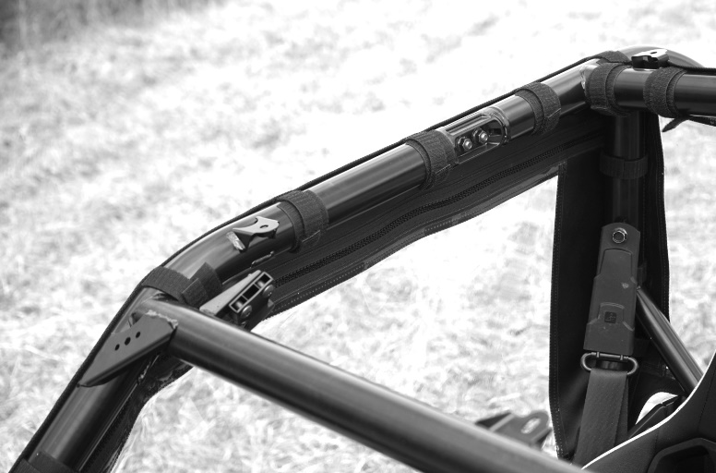
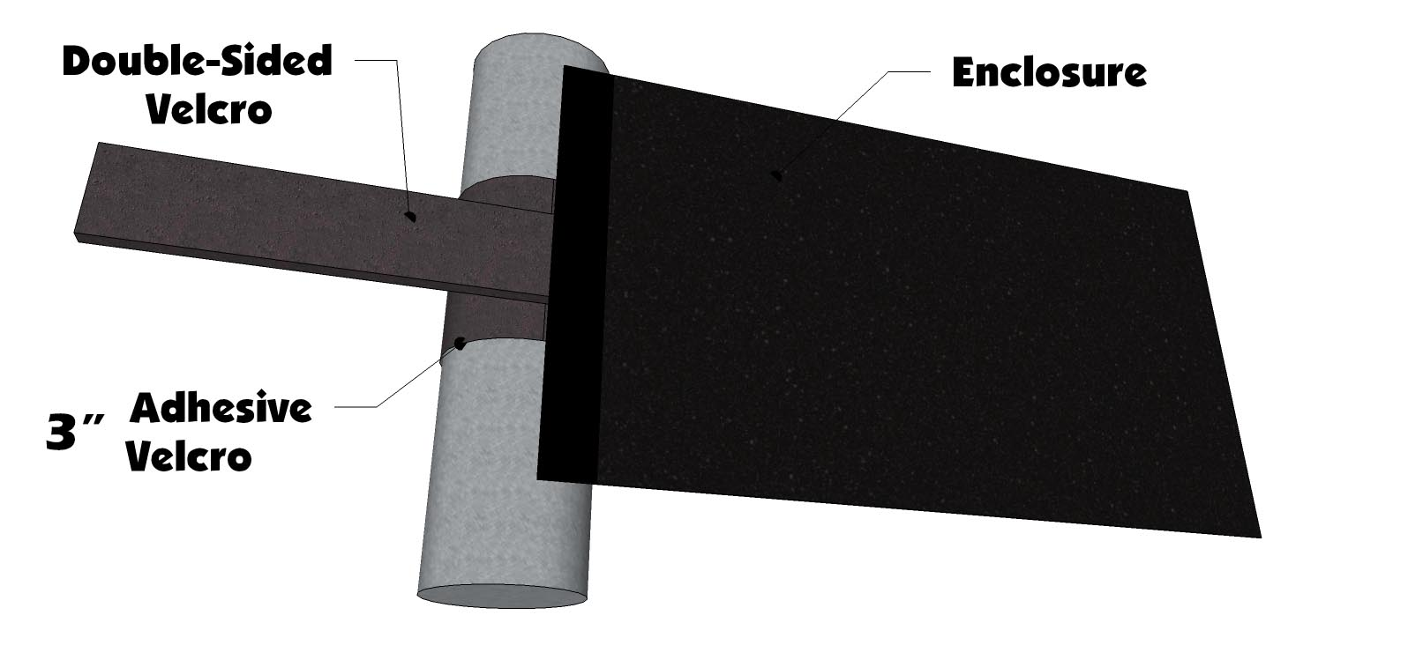
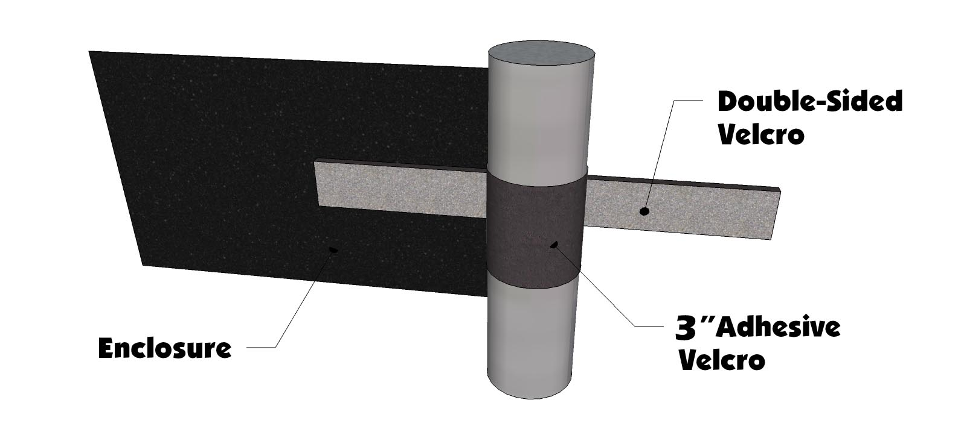
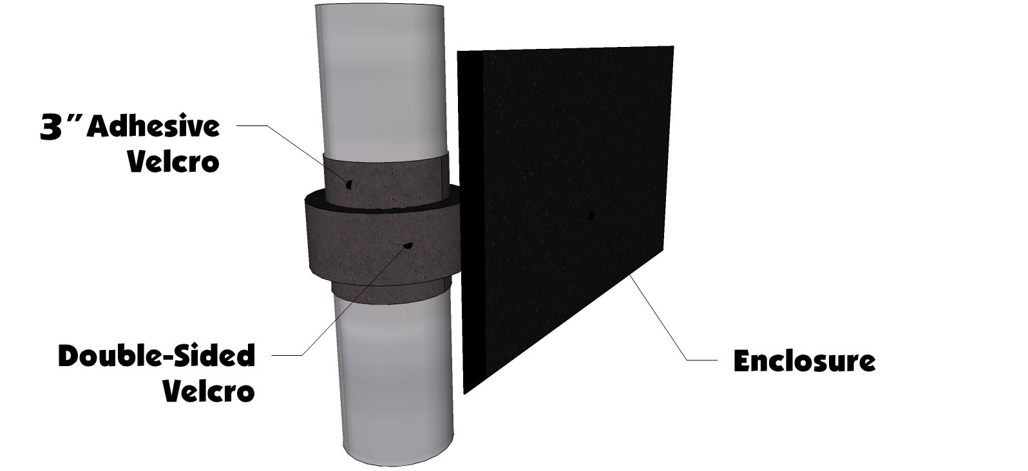

- After attaching the double-sided strips go to the bottom of the door. Pull the bottom of the door up and place the 40” adhesive strip on the Velcro sewn to the door. Leave the paper backing on it as you put it on then peel it off after getting it in place. See Photos below.

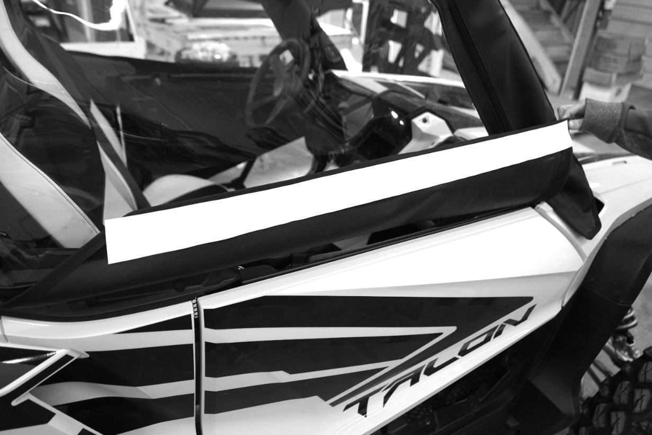

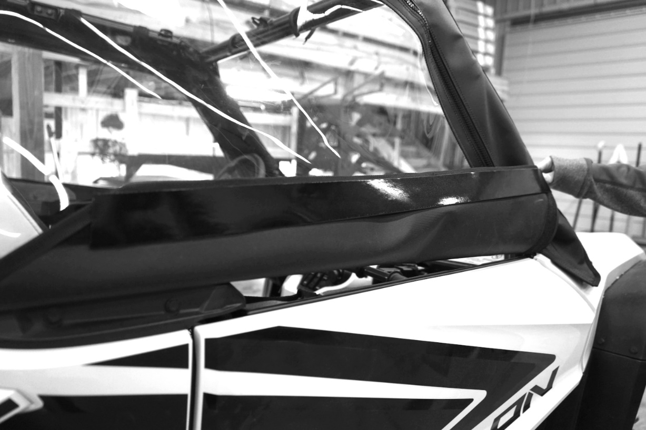

- Then pull the bottom of the door down and attach it to the Talon door. Make sure to rub it down good before peeling the door back off the Velcro.

- Remove the bottom of the door and take a knife and cut the Velcro where the back of the door hinges at. See photo below

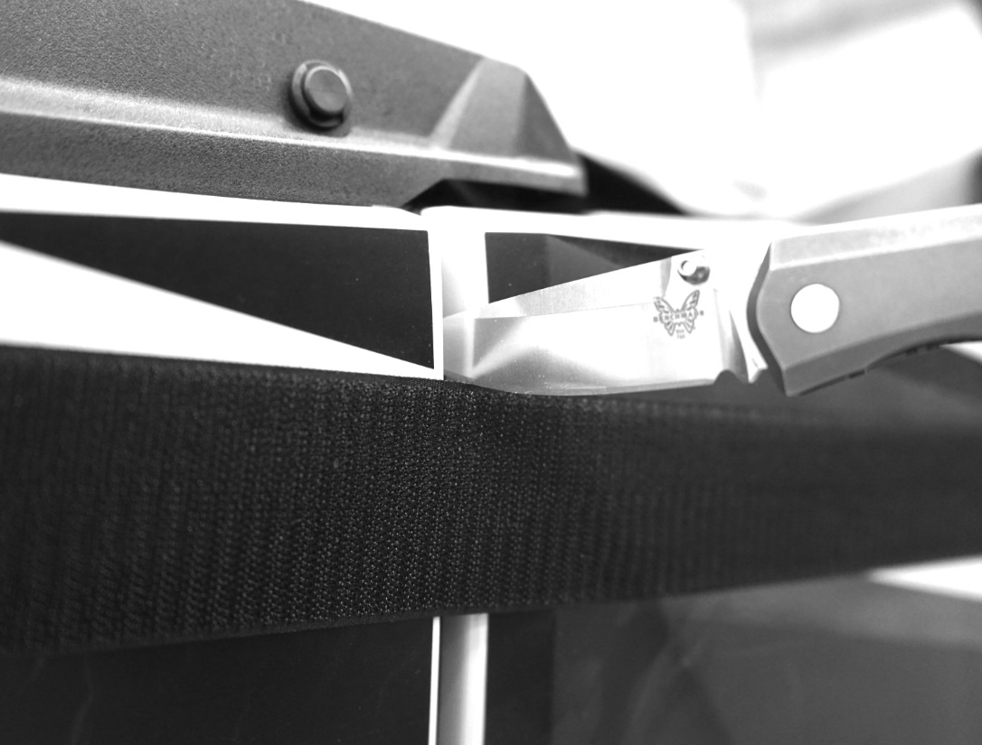

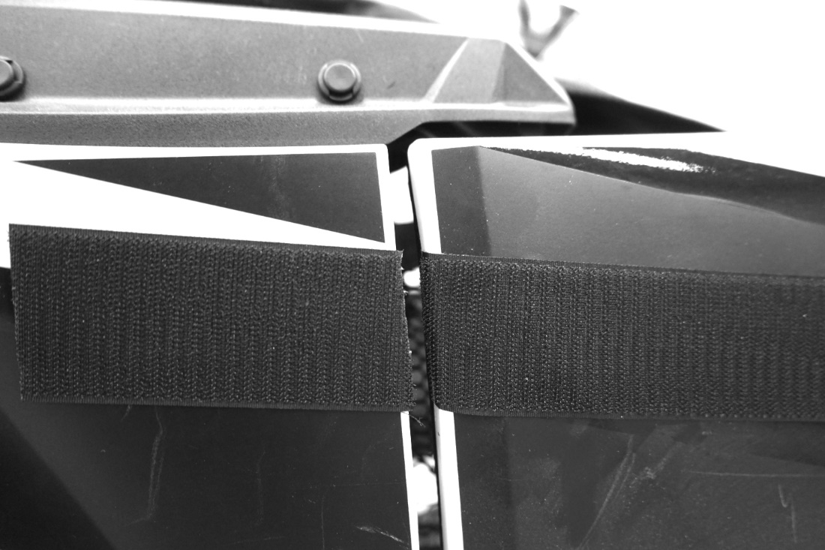

- Next place the 6” adhesive strips on the vehicle to match up with the front portion of the door as shown in the photo below.

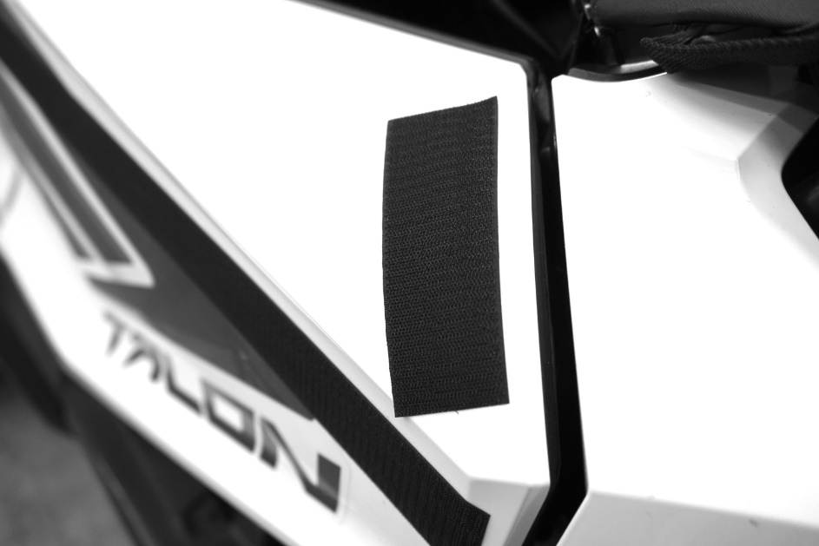

- Lastly place the other 6” adhesive strips on the vehicle to match up with the Velcro on the very front bottom part of the door as shown below.

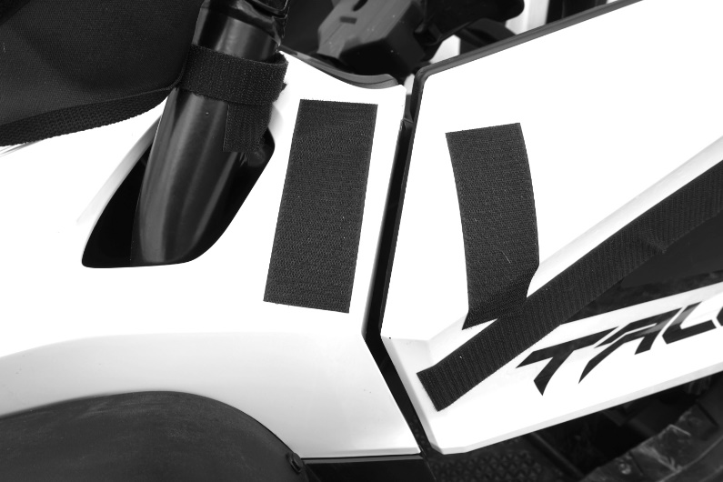

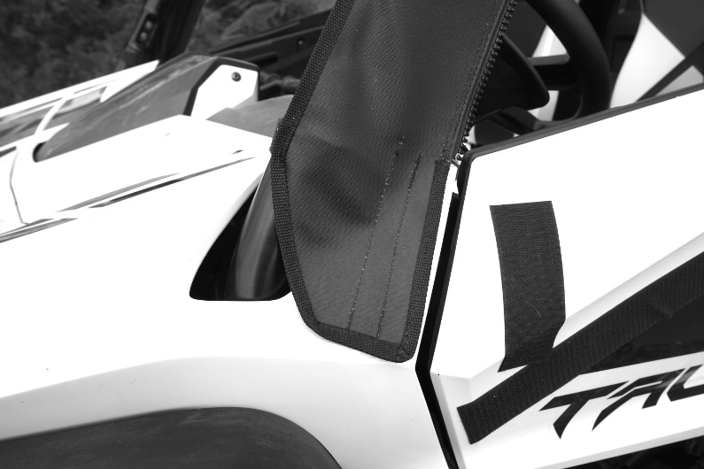
Cleaning and Storage Recommendations:

- Before removing the enclosure for storage, make sure it is clean and dry, to prevent soiling the textile and scratching the clear vinyl side/rear windows. Clean with a soft rag or sponge using a mild liquid detergent soap and warm water solution. Let the enclosure dry thoroughly before attempting to roll for storage.

- It is important that the enclosure be rolled up for storage rather than folding. Folding will cause undesirable creasing of both the enclosure textile and the clear vinyl side/rear windows. Carefully roll up the enclosure similar to the way it was when it was packed at the factory. On a large, clean, and flat surface, fold the doors over the rear panel first, then, interleave the top and windshield on top of the doors. Begin rolling the enclosure into a roll approximately 8” in diameter. Put the rolled enclosure back into the carton for storage at a normal room temperature. It is best not to expose the enclosure to either extreme hot or cold temperatures when storing.

- Transporting or trailering your UTV with the enclosure installed is not generally recommended. It is best to remove the enclosure before transporting your UTV.

If you have any questions, comments, need assistance, or are missing parts, please contact us by one of the methods below.




WARNING: This product contains a chemical known to the State of California to cause cancer. For more information, go to www.P65Warnings.ca.gov.

