

51-21002- Instructions for Polaris Turbo S Soft Door Kit
(PO-TURBOS-SDK01)

Notice: Do not smoke inside the cab or expose the enclosure to direct flames. Product is FLAMMABLE.

Be sure to read these instructions thoroughly before opening and installing the enclosure. The installation is best done when ambient temperature is 70°F or warmer. If installed in cold weather, warming the adhesive Velcro strips before installation is recommended.

- Carefully open the carton and remove the rolled up Cab Enclosure on a large flat surface that is clean and free of dirt or other material that may soil or scratch the windows of the Cab.

- Check over the parts included in the carton with the parts list shown below:
Doors:
Velcro Hook strips Qty Length
2 37” long
2 30” long
4 14” long
2 9” long
20 3” long

Door Panels 2 each

- Door Panels
  - Begin installation by hanging the Door Panels from the top by using the 3” adhesive Velcro strips as shown in the photos on the next page:

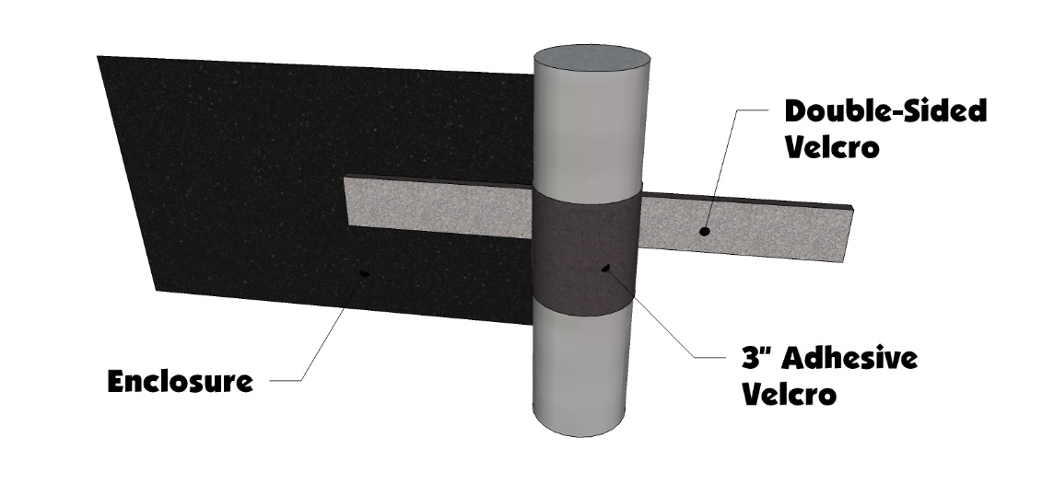

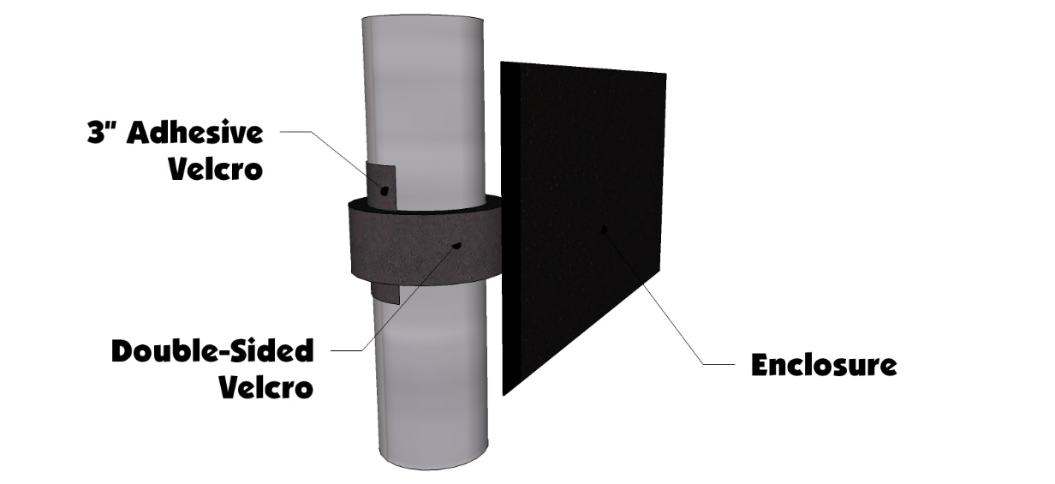
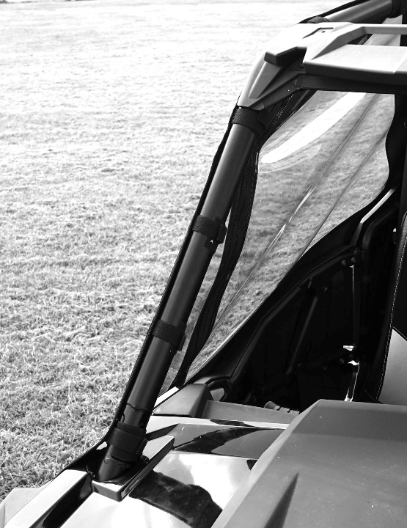

  - After installing the double-sided strips move to the top of the door and attach the 37” adhesive hook strip starting at the front and work it on the bar towards the rear. The strip will start on the side of the bar and end up on top of the bar at the rear. See Photo Below:

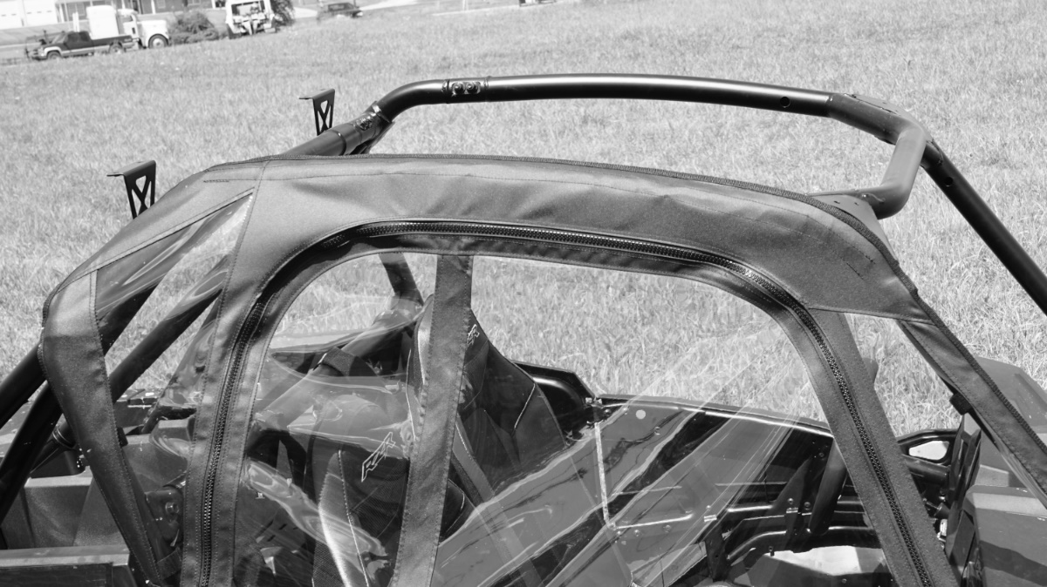

  - Next attach the bottom of the door to the plastic doors on the RZR. Use the 30” adhesive strip and one of the 14” adhesive strip to attach the soft door to the plastic. Then use another 14” adhesive strip to attach the bottom of the front wing to the side of the hood. See photo below:

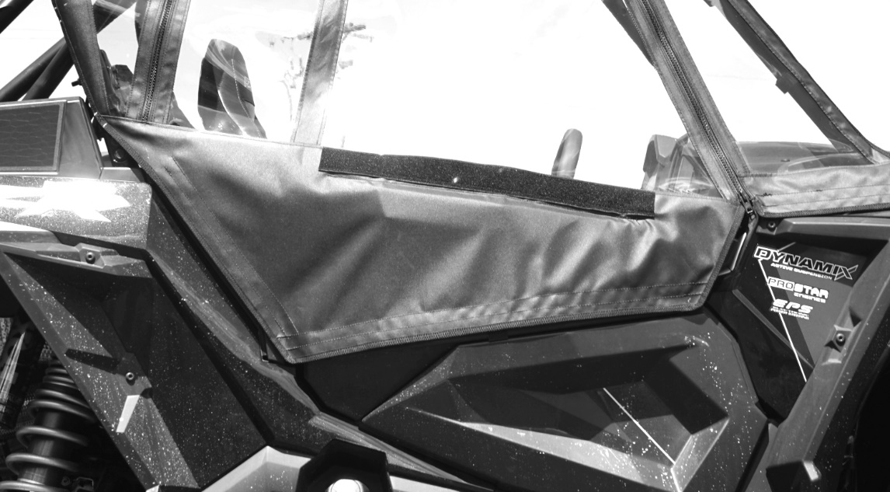

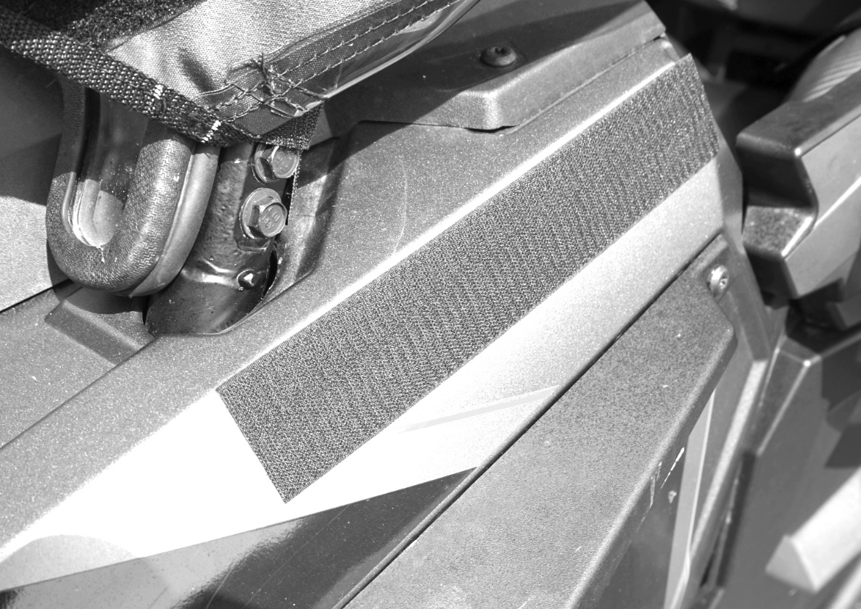

  - Lastly attach the two flaps on the inside of the door to the inside of the metal frame of the factory door. These pieces are there to hold the bottom of the door in place when the door is rolled down so it doesn’t fall away from the door. See photo below
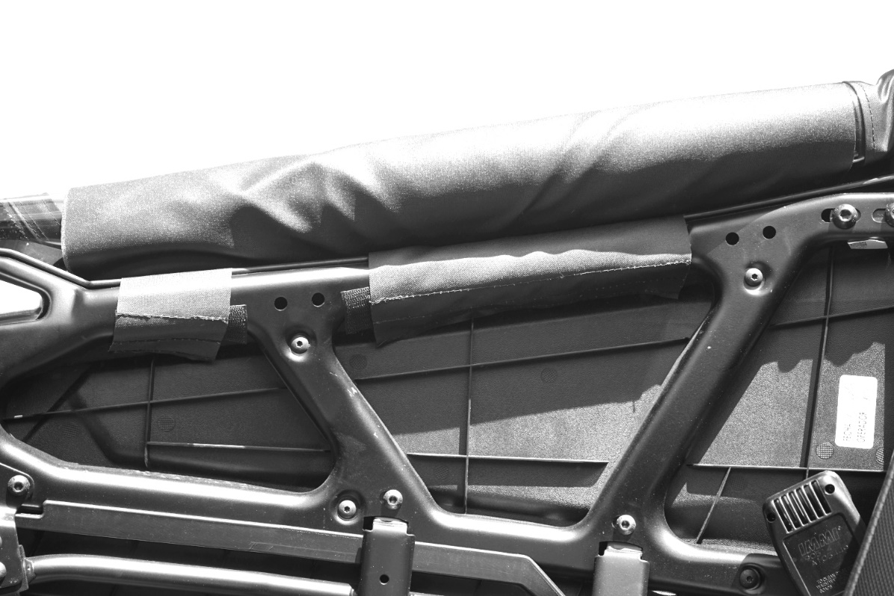

  - When you want to roll the windows down, be sure to unzip it fully and roll it down in a tight roll towards the inside of the vehicle. Then take the panel hanging on the inside and wrap it around the roll and attach it to the Velcro on the outside of the door just under the window as shown in the photo below.

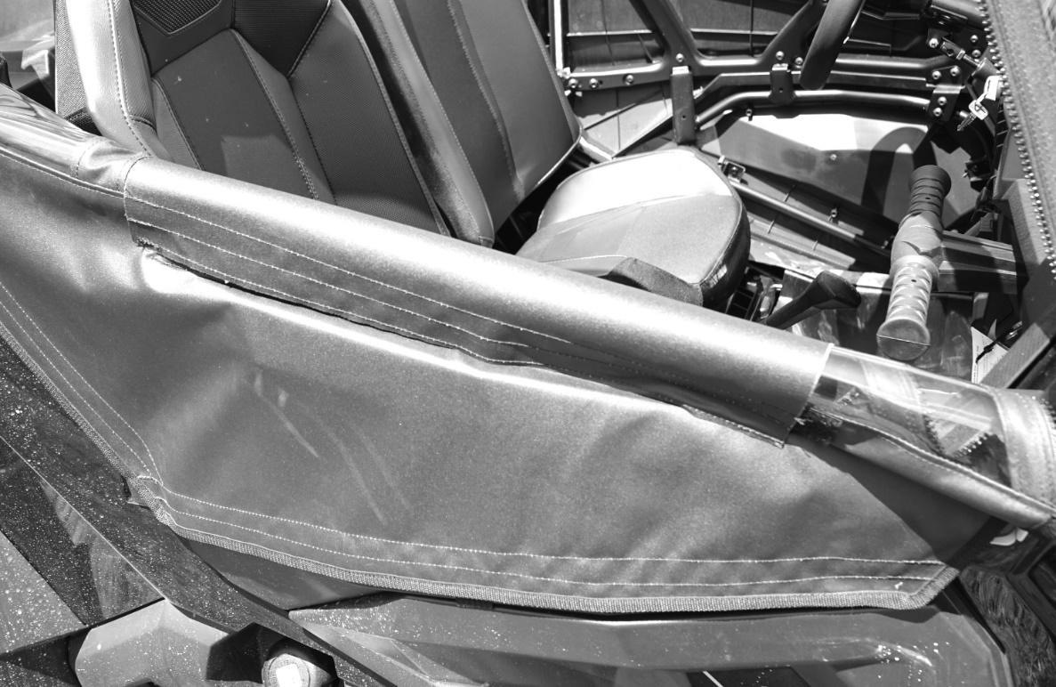

Cleaning and Storage Recommendations:
- Before removing the cab for storage, make sure it is very clean in order to prevent scratching of the window panels. Clean with a soft rag or sponge using a mild liquid detergent soap and warm water solution. Never rub the windows with a dry cloth or rag! Let the Cab dry thoroughly before attempting to roll for storage.

- It is important that the Cab be rolled up for storage rather than folding. Folding will cause damage to the windows!!! Carefully roll up the Cab similar to the way it was when it was packed at the factory. On a large, clean and flat surface, fold the doors over the rear panel first, then, interleave the top and windshield on top of the doors. Begin rolling the Cab into a roll approximately 8 inches in diameter. Put the rolled Cab back into the carton for storage at a normal room temperature. It is best not to expose the Cab to either extreme hot or cold temperatures when storing.

If you have any questions, comments, need assistance, or are missing parts, please contact us by one of the methods below.



WARNING: This product contains a chemical known to the State of California to cause cancer. For more information, go to www.P65Warnings.ca.gov.

