
1-800-213-7981
Instructions for Installation and Care of Polaris General 1000 Crew Soft Door Kit
52-10160-Z - PO-GENERAL-CREW-SDK01

Caution: Do not smoke inside the cab or expose the enclosure to direct flames. Cab is Flammable.

Be sure to read these instructions thoroughly before opening and installing the enclosure. The installation is best done when the temperature is 70 degrees F. or warmer. The temperature affects the adhesive Velcro, if conditions prevent installing in warmer weather it helps to store the adhesive Velcro at room temperature prior to installation.

- Carefully open the carton and remove the rolled-up Cab Enclosure on a large flat surface that is clean and free of dirt or other material that may soil or scratch the windows of the Cab. Check over the parts included in the carton with the parts list shown below:

Velcro Hook strips:
4 each 6” long
2 each 9” long
4 each 10” long
2 each 12” long
2 each 15” long
2 each 18” long
4 each 20” long
2 each 22” long
2 each 24” long
2 each 33” long

If any parts are damaged or missing, please contact customer service at 1-800-213-7981
.

- Begin by Cleaning roll cage from front to back along the outside edges of the doors. It helps but is not necessary to remove the plastic. Next, attach a series of adhesive Velcro strips around the roll cage. Starting from the front the first strip should begin at the weld spot just above the bolts. 1) 22” 2) 24” 3) 33” 4) 12” 5) 18” 6) 6”

- Next place the adhesive Velcro strips along the top outside edges of the factory doors. The following order is the lengths from front to back. 1) 6” 2) 10” 3) 9” 4) 15” 5) 20” 6) 10”

- The following pictures show how this should look after all the Velcro is installed.

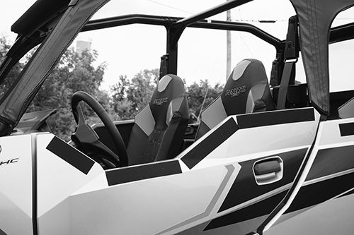

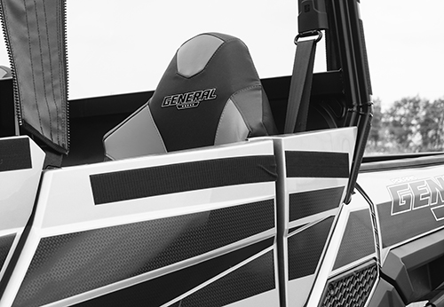

Cleaning and Storage Recommendations:

- Before removing the Cab for storage, make sure it is very clean in order to prevent scratching of the window panels. Clean with a soft rag or sponge using a mild liquid detergent soap and warm water solution. Never rub the windows with a dry cloth or rag! Let the Cab dry thoroughly before attempting to roll for storage.

- It is important that the Cab be rolled up for storage rather than folding. Folding will cause damage to the windows!!! Carefully roll up the Cab similar to the way it was when it was packed at the factory. On a large, clean and flat surface, fold the doors over the rear panel first, then, interleave the top and windshield on top of the doors. Begin rolling the Cab into a roll approximately 8 inches in diameter. Put the rolled Cab back into the carton for storage at a normal room temperature. It is best not to expose the Cab to either extreme hot or cold temperatures when storing.

Thank you for your purchase!

Warranty

To The Owner of this Product:

Thank you for purchasing one of our Falcon Ridge Cab Enclosures, Tops &/or Windshields! Below are the terms under which your product is covered under our manufacturer’s warranty.

30 Day Warranty which includes and is not limited to replacing the enclosure, tops and/or windshield due to defect of the product. Please refer to the return policy in this case for more information.

1 Year Warranty includes any defect in material or workmanship within this time frame we will gladly correct the problem or replace the enclosure, tops &/or windshield. Upon submitting for the correction or replacement we will need to receive pictures of the defect in material or workmanship along with the receipt from the date of purchase.


WARNING: This product contains a chemical known to the State of California to cause cancer. For more information, go to www.P65Warnings.ca.gov.

